CPCS 324: Algorithms and Data Structures (II)

Group Project – Group 22

Phase 2:Dijkstra algorithm for the single-source shortest path problem and DBAllsourceSPAlg

|  |  |  |
| --- | --- | --- |
| Section | Name | ID |
| B9B | Hanin Suleiman Omer Alhaj | 2010269 |
| B8 | Dhay Mohammed Alharbi | 1905483 |
| B8 | Roaa Ahduallah Alzahrani | 2005863 |
| B9B | Alaa Emad Alhamzi | 2010304 |

Table of Contents

1 Introduction 4

2 Input Samples 4

3 Dijkstra Algorithm 5

4 Analysis of Algorithm 6

5 Screenshot of output 7

6 Difficulties 7

7 Conclusion 7

Assignment task:

|  |  |  |
| --- | --- | --- |
| Responsibility | Name | ID |
| All work shared between group member | Hanin Suleiman Omer Alhaj | 2010269 |
| Dhay Mohammed Alharbi | 1905483 |
| Roaa Ahduallah Alzahrani | 2005863 |
| Alaa Emad Alhamzi | 2010304 |

# 1 Introduction

Empirical analysis is a method for studying and interpreting data that is based on empirical research. Information that can be gleaned through experience or by using the five senses is known as empirical evidence. Theoretical analysis investigates how the problem's decision-making processes, unique characteristics of the problem description. In this project we use Dijkstra algorithms to analyze the graph to find the shortest path between the source node and all the other nodes in the graph.

# 2 Input Samples

On graphs that are produced at random, where n is the number of nodes and m is the number of edges, the algorithm will be put to the test.

n=2000 and m= 10000

n=3000 and m= 15000

n=4000 and m= 20000

n=5000 and m= 25000

n=6000 and m= 30000

# 3 Algorithms

## 3.1 Dijkstra Algorithm

The Dijkstra's algorithm (/dakstrz/ DYKE-strz) is a method for determining the shortest routes between nodes in a weighted graph, which may, for instance, be a representation of a network of roads. Edsger W. Dijkstra, a computer scientist, came up with the idea in 1956, and it was published three years later.

There are numerous variations of the algorithm. A more popular variation fixes one node as the "source" node and finds shortest paths to all other nodes in the graph, resulting in a shortest-path tree. Dijkstra's initial technique identified the shortest path between two supplied nodes.

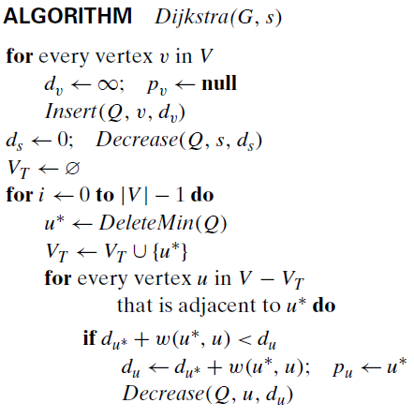

# 4 Analysis of Algorithm

We will use the running time to empirically determine and compare it with the theoretical time efficiency.

|  |  |  |  |
| --- | --- | --- | --- |
| N (v) | M node (E) | Running time of algorithm (n) | Expected theoretical time efficiency (v^2)*V |
| 2000 | 10000 | 4634 | 8000000000 |
| 3000 | 15000 | 15382 | 2.7x(10)^10 |
| 4000 | 20000 | 36736 | 6.4x(10)^10 |
| 5000 | 25000 | 70872 | 1.25x(10)^11 |
| 6000 | 30000 | 12249 | 2.16x(10)^11 |

|  |  |  |
| --- | --- | --- |
|  | Ratio of running time | Ratio of expected time efficiency |
| Time of 2000/time of 3000 | 0.3012612144 | 0.2962962963 |
| Time of 3000/time of 4000 | 0.4187173345 | 0.421875 |
| Time of 4000/time of 5000 | 0.5183429281 | 0.512 |
| Time of 5000/time of 6000 | 5.78594171 | 0.5787037037 |

We notice that the values ​​between the Ratio of running time increase closely, except for the last one, where the last value increases by a large difference from the preceding one compared to the previous values. We also note that the values ​​between the running time ratio and the expected time efficiency ratio are close except for the last value.

# 5 Screenshots of output

# 6 Difficulties

The project has been confronted with considerable challenge in relation to algorithm programming and implementation. These difficulties have resulted in complications throughout the project's entirety.

# 7 Conclusion

On the basis of directed weighted graph, we built the Dijkstra algorithm for the shortest path general problem. The Dijkstra algorithm's empirical analysis and theoretical time efficiency were extremely similar except of the last one.

References:

1-Wikimedia Foundation. (2023, May 28). *Dijkstra’s algorithm*. Wikipedia. https://en.wikipedia.org/wiki/Dijkstra%27s_algorithm

2-Levitin, A. (n.d.). Introduction to the Design and Analysis of Algorithms

(3rd Edition) by Anany Levitin, Pearson. Pearson

3-Wright, G. (2022, October 4). *What is empirical analysis and how does it work?*. WhatIs.com. https://www.techtarget.com/whatis/definition/empirical-analysis